**Angular2 Application**

**Client side app**

**Used technology – Angular 2**

MyTrips is application which will help you to save your visited places in the world and attach images for them. You are able to search places in google map with autocomplete or navigate manual to the place and save it. Also you can save places which you want to visit they will be added in personal wish list.

**Project architecture:**

For user authentication we are using Identity Server which send us unique access token.

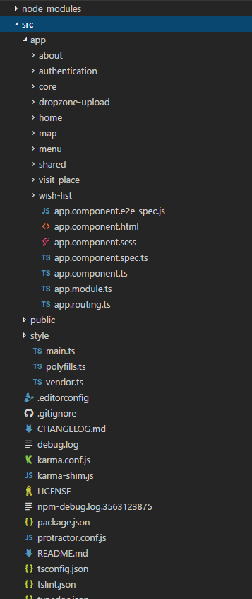

**Server side**

**Used technology – ASP.NET WebApi 2 , Identity Server 3, C#, Entitiy Framework**

**Project architecture:**

